User Manual

Blood Requester (Member):

1. All new Members can enter into our website with their basic details like (Name,Email,Phone,Address,Age,Password etc) through this signup page.

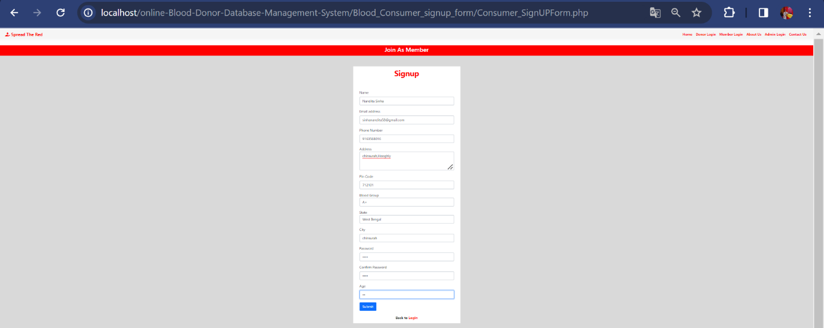

1. After submitting the sign up form, a random 6 digit otp will be sent to the member’s specified email address.

The member should put the otp correctly into the otp modal for completing the sign up process.

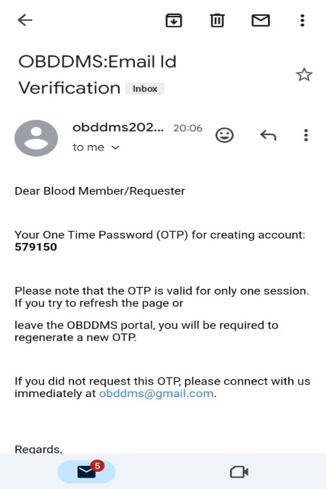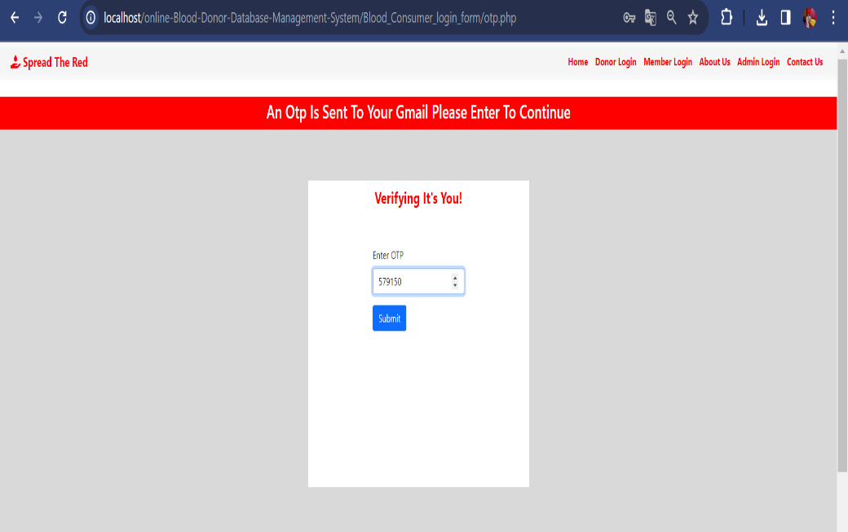

1. If the entered OTP is invalid, an error message will be displayed and member should enter the correct otp again.

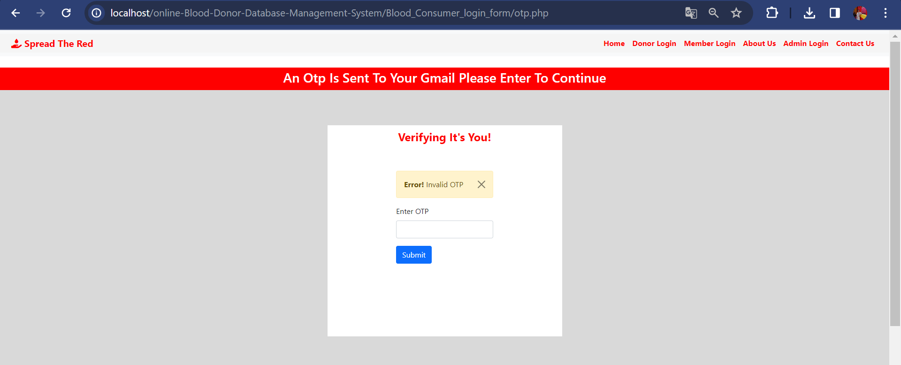

1. Members will be redirected to the login page after completing the signup process. Where they can put their email address, and password.

If the credentials do not match, an error message will be displayed.

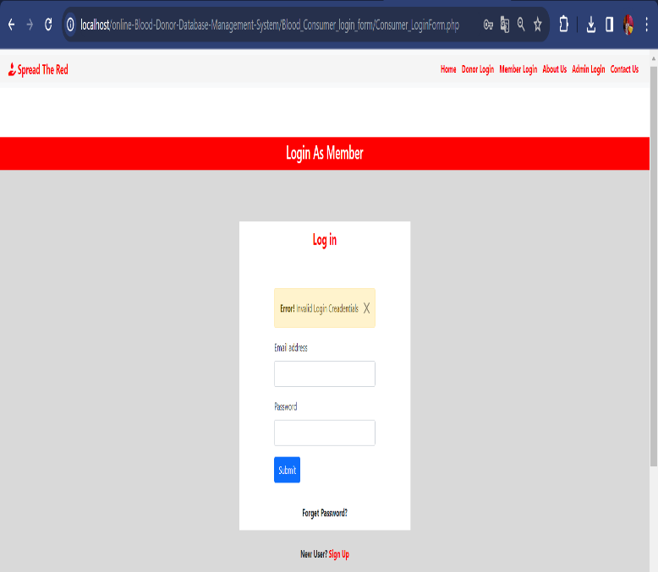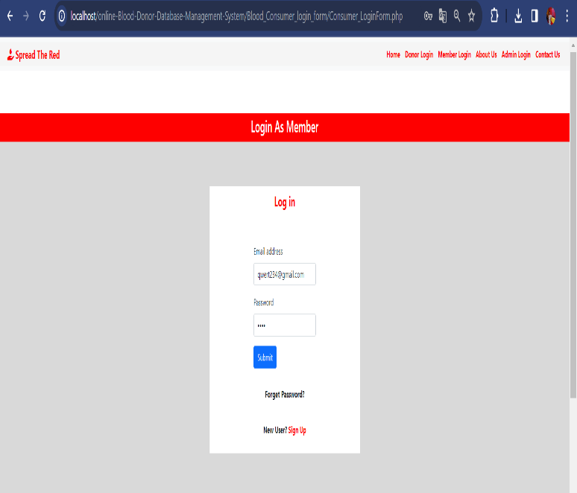

1. 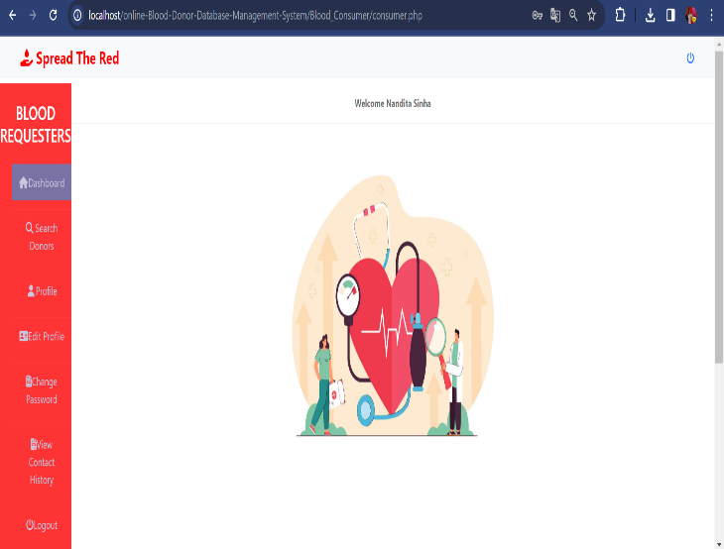Otherwise the login process is complete and the member will be redirected to the Dashboard.

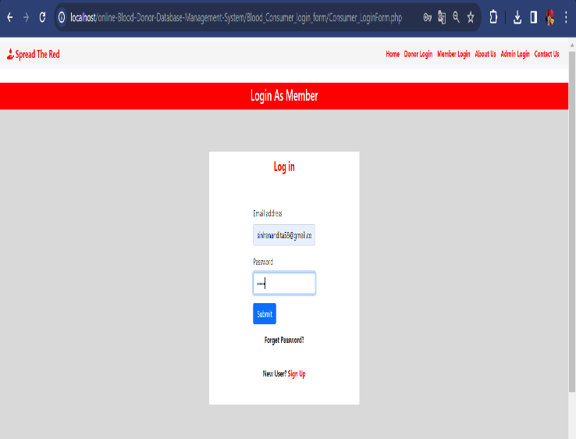

1. 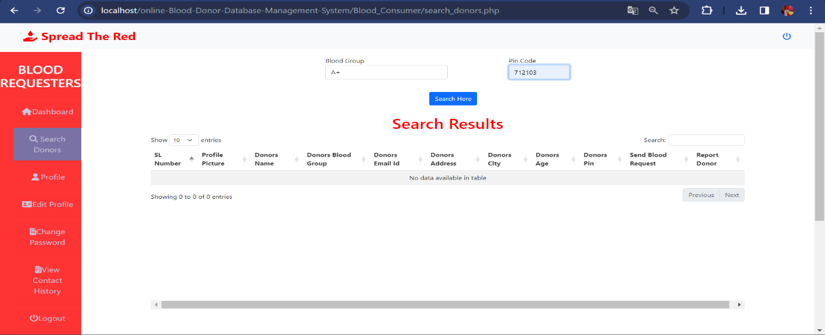In the 'Search Donors' option, members can search for the respective donor based on their required Blood Group and pincode.
2. 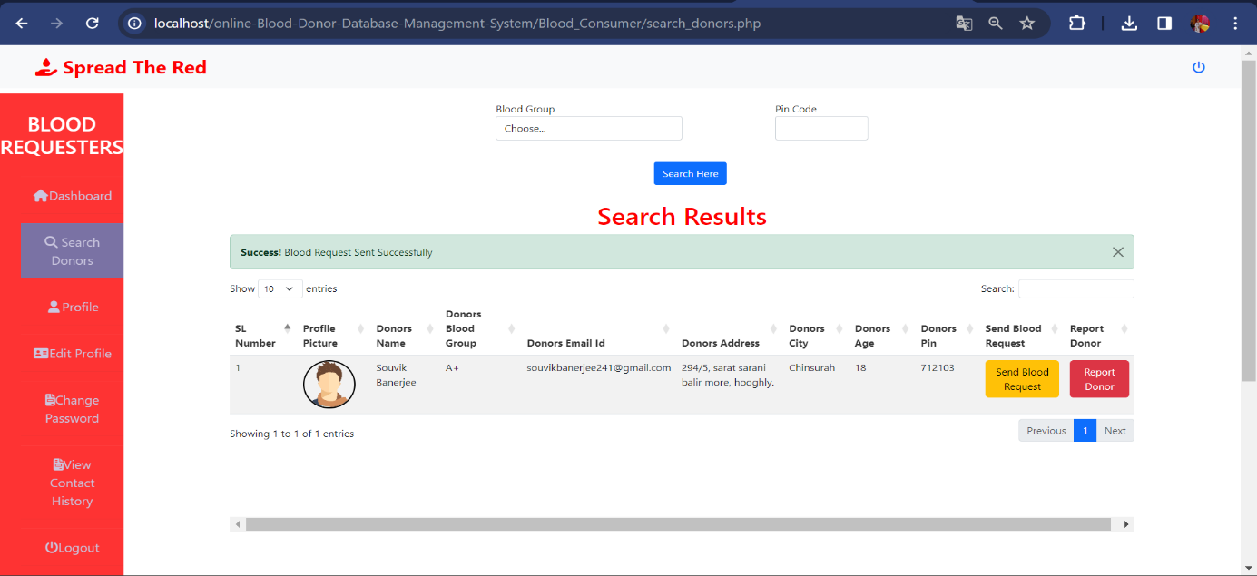The available donor list will be displayed for that particular pin code.
3. If the member sends the request, a request message will be sent to the donor's email address.

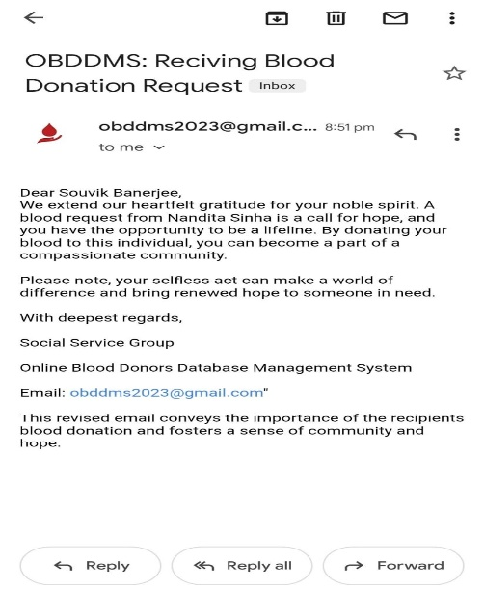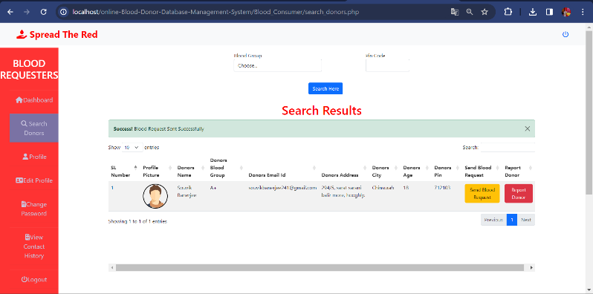

1. Until the donor either accepts or rejects the request, the member's status will be displayed as 'pending'. The donor’s contact no also hidden.

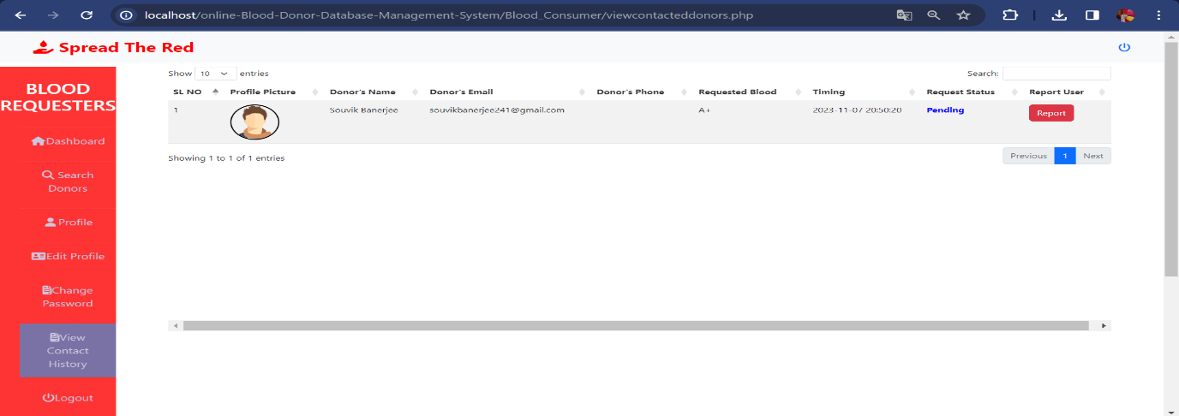

1. When the donor accepts the request, the status will be updated to 'Accepted'. Simultaneously the donor contact will be unhided to that particular member.

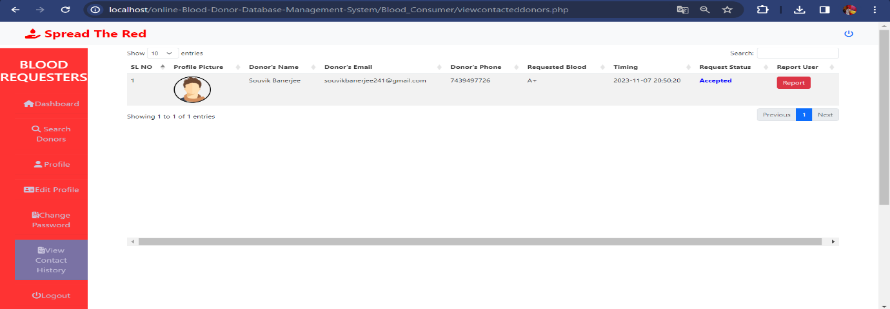A system generated receive request email will be sent to the requester email.

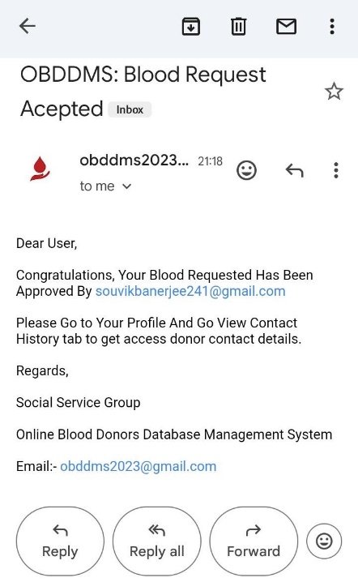

1. 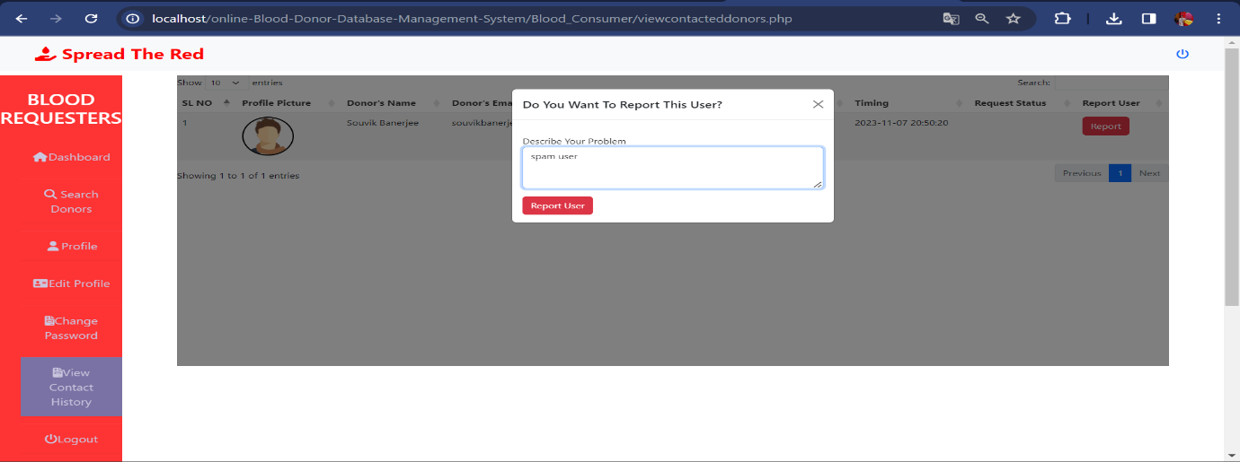We try to increase the security of this whole process and that’s why we add the report feature. In which a particular member can reported against the in-appropriate donor.
2. The report successfully sent to the admin pannel.

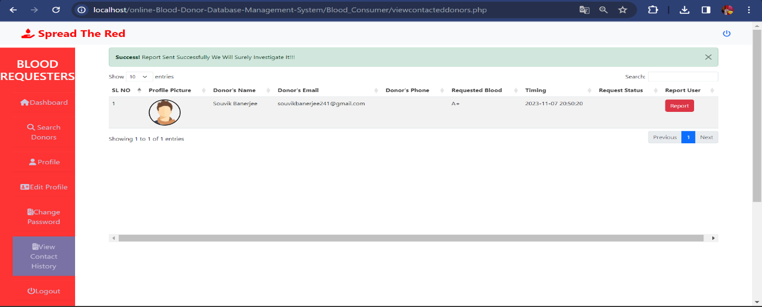

1. The member can view their profile through the ‘Profile’ option.

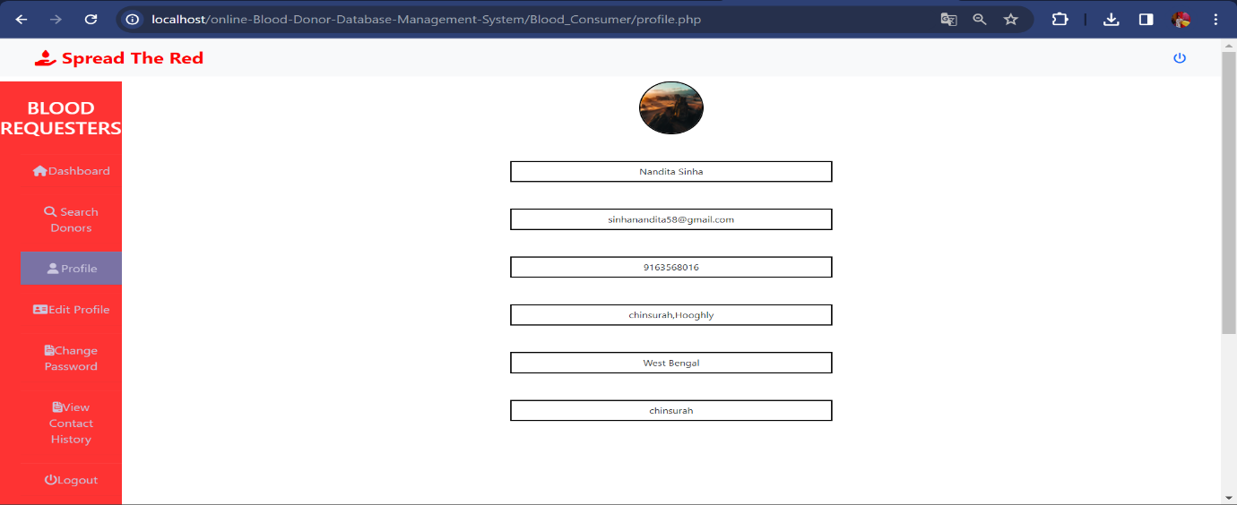

1. Member also will be able to edit their basic account details via ‘Edit Profile’ option.

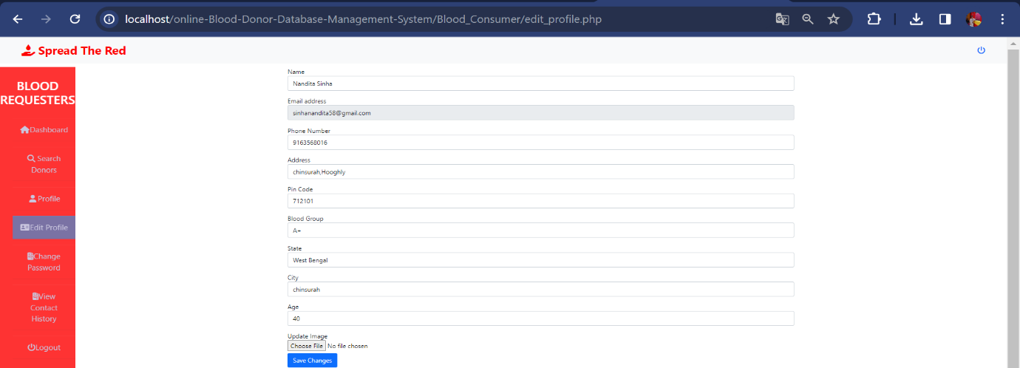

1. 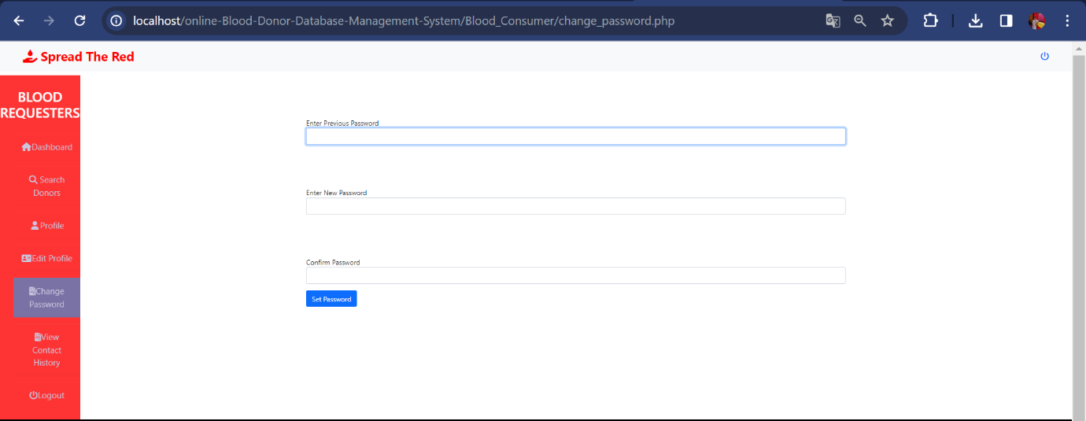Any time a member can change their password through the ‘Change Password’ option.